The Transylvania County Building Permitting and Enforcement Department invites you to their Code Officials Qualification Board approved Continuing Education Course.
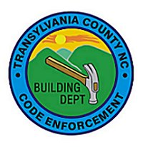

Sponsored By
NC Department of Insurance
Engineering and Codes Division

Building Course #CS3987
2018 Code Requirements for Multi-Family Housing
Type A and Type B Units

Six Credit Hours Earned

Date: Friday, October 19, 2018
Time: 9:00 am - 4:00 pm
Location: Transylvania County Library (Rogow Room)
212 S Gaston St, Brevard, NC
Cost: No charge
Instructor: Laurel Wright, Chief Accessibility Code Consultant

Registration:
To register, please send email to Sherry Reece (sherry.reece@tconc.org) or Beverly McJunkin (beverly.mcjunkin@tconc.org). Provide your name, jurisdiction and CEO ID number.

Call: (828) 884 3209, Ext 1 if you have any questions.

