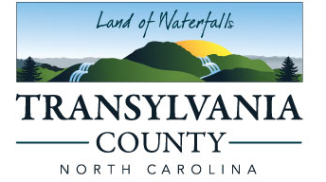
BOARD OF COMMISSIONERS COUNTY MANAGER
Jason Chappell, Chair Jaime Laughter
Jake Dalton, Vice-Chairman 828-884-3100
Emmett Casciato Fax 828-884-3119
Larry Chapman
Teresa McCall 101 South Broad Street
Brevard, NC 28712

Request for Qualifications
Professional Architectural/Engineering/Designing Services/Construction Admin
For Transylvania County Courthouse

Transylvania County is inviting interested architectural design/consulting engineering firms, licensed in the State of North Carolina, to send their qualifications for consideration to supply professional architectural/engineering/planning/construction phase services for the Transylvania County Court House.

The RFQ will be released Wednesday, September 13, 2023. You may obtain a copy by email request to jennifer.galloway@transylvnaiacounty.org or on the website at www.transylvnaiacounty.org . In order to be considered all responses must be submitted in writing no later than 4:00PM EST on Wednesday, October 11, 2023. Firms mailing responses should allow delivery time to ensure timely receipt of their proposals. The responsibility for getting the response to Transylvania County’s Purchasing Agent on or before the specified time and date is solely and strictly the responsibility of the responding firm. The County will in no way be responsible for delays caused by any occurrence. Late responses will be deemed invalid. Responses may be hand delivered or mailed to:
Transylvania County – Purchasing Agent
Attn: Jennifer Galloway
101 S Broad Street
Brevard, NC 28712
Transylvania County Board of Commissioners reserves the right to waive any informalities, to reject any and all responses to the Request for Qualifications, and to accept any responses which in its opinion may be in the best interest of Transylvania County.

